**Deploying Apps in Tomcat server**

## Installing Java and Setting the Java Environment Variable

## Tomcat requires java in order to run.

Here are the steps for setting the environment variable on my computer (Windows XP Professional). The steps will probably be similar for other Windows computers.

Open the control panel under the start menu.

Double-click on System.

Click on the Advanced tab.

Click on the Environment Variables button.

Under System Variables, click on the New button.

For variable name, type: JAVA_HOME

For variable value, type: C:\j2sdk1.4.2_01

Continue to click OK to exit the dialog windows.

## Installing Tomcat

After setting the JAVA_HOME environment variable, you can install tomcat.

1. Go to the [Tomcat Web page](http://jakarta.apache.org/tomcat/).
2. Click on Binaries under the Download label on the left side of the page.
3. Scroll down until you see Tomcat 4.1.x. (x will be some number greater than 10).
4. Click on the link ending with exe (e.g. 4.1.27 exe).
5. Download and run the exe file.
6. I suggest you install Tomcat at c:\tomcat4
7. Use the default settings and provide a password that you will remember.
8. now assume that your tomcat are installed at c:\tomcat4

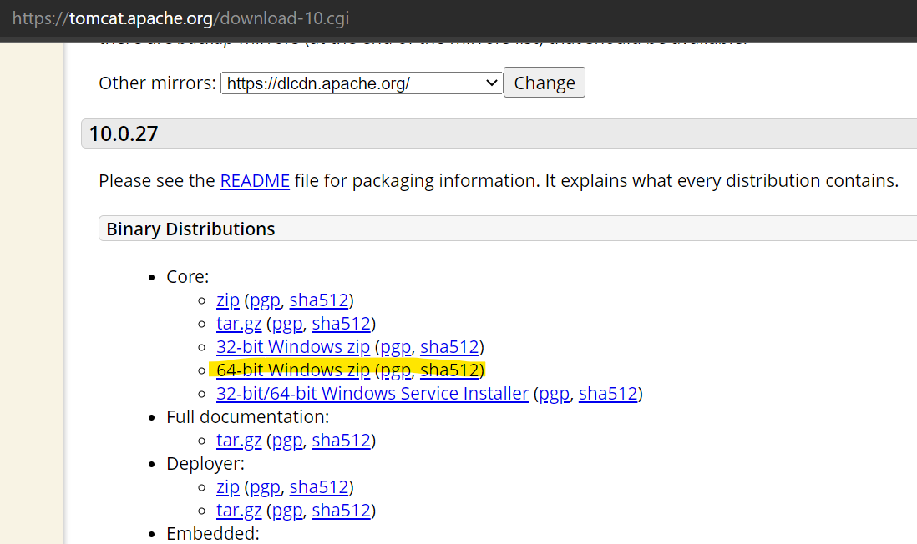

**Running Tomcat**

Here are the steps to see if Tomcat has been successfully installed

1. Start Tomcat by finding its start program in the Programs Menu (located in the Start menu). Look under Apache Tomcat 4.1 and select "Start Tomcat".
2. Open a Web browser and type in the following URL:
   * http://localhost:8080/

## 

## Create a simple web application

## Webapps will be deployed into webapps folder under tomcat,

## Create a sample folder in it and deploy html page

## 

## Now give the url localhost:8080/webapps/sample/hello.html

## 

## Problems faced

## When u are not able to access tomcat then give usename and password in tomcat.server file

## Starting up server: in cmd, give tomcat bin path and give startup/win+R🡪services.msc🡪start the server. You can stop and restart the server.

## 